CSA 4302 - INTERNET PROGRAMMING

LAB EXPERIMENT 01:

AIM : To design and develop a Library Management System website that streamlines library operations by providing book catalog management, student registration and login, book issue and return tracking, fine calculation, and year- and semester-wise study material management. The system enables students to search for books, view borrowing history, check fines, and download study materials, while librarians can efficiently manage book inventory, student records, and library transactions.

CODE:

<!doctype html>
<html lang="en">
<head>
<meta charset="utf-8">
<meta name="viewport" content="width=device-width, initial-scale=1">
<title>Cornerstone Library</title>
<style>
:root {
color-scheme: light;
--ink: #24312d;
--muted: #68756f;
--paper: #f7f8f4;
--card: #fff;
--green: #27634f;
--green-dark: #194b3a;
--line: #e3e9e3;
--accent: #eaf2ed;
--danger: #a43c34;
font-family: Inter, ui-sans-serif, system-ui, -apple-system, BlinkMacSystemFont, "Segoe UI", sans-serif;
}
* { box-sizing: border-box; }
body { margin: 0; background: var(--paper); color: var(--ink); }
button, input, select, textarea { font: inherit; }
button { cursor: pointer; }
header { background: var(--card); border-bottom: 1px solid var(--line); }
.header-inner { max-width: 1100px; margin: auto; padding: 16px 24px; display: flex; align-items: center; justify-content: space-between; gap: 18px; }
.brand { font-size: 1.15rem; font-weight: 750; color: var(--green-dark); letter-spacing: -.03em; }
.brand span { color: #9a7952; }
nav { display: flex; gap: 7px; flex-wrap: wrap; }
nav button, .link-button { background: transparent; border: 0; color: var(--muted); padding: 9px 11px; border-radius: 8px; }
nav button:hover, nav button.active { background: var(--accent); color: var(--green-dark); }
.header-actions { display: flex; align-items: center; gap: 10px; }
.user-label { color: var(--muted); font-size: .9rem; }
.container { max-width: 1100px; padding: 36px 24px 60px; margin: auto; }
.hero { display: grid; grid-template-columns: 1.4fr .8fr; gap: 28px; align-items: center; background: #eaf1e9; border-radius: 18px; padding: 34px; margin-bottom: 30px; }
.eyebrow { color: var(--green); text-transform: uppercase; letter-spacing: .12em; font-size: .75rem; font-weight: 700; }
h1 { font-size: clamp(2rem, 5vw, 3.2rem); line-height: 1.05; letter-spacing: -.05em; margin: 10px 0 14px; }
h2 { letter-spacing: -.03em; margin: 0 0 8px; }
h3 { margin: 0 0 8px; }
p { color: var(--muted); line-height: 1.6; }
.hero p { max-width: 530px; margin: 0 0 20px; }
.hero-art { min-height: 185px; border-radius: 14px; background: linear-gradient(145deg, #cbdccd, #e8d9bd); display: grid; place-items: center; font-size: 5rem; }
.button { border: 1px solid var(--green); border-radius: 8px; padding: 9px 13px; background: var(--green); color: white; font-weight: 650; }
.button:hover { background: var(--green-dark); }
.button.secondary { color: var(--green-dark); background: white; }
.button.secondary:hover { background: var(--accent); }
.button.danger { background: white; color: var(--danger); border-color: #e5b9b5; }
.button.small { padding: 6px 9px; font-size: .86rem; }
.section-heading { display: flex; justify-content: space-between; align-items: end; gap: 14px; margin: 28px 0 15px; }
.section-heading p { margin: 4px 0 0; }
.grid { display: grid; grid-template-columns: repeat(3, 1fr); gap: 16px; }
.card { background: var(--card); border: 1px solid var(--line); border-radius: 12px; padding: 18px; }
.book-card { display: flex; flex-direction: column; min-height: 195px; }
.book-card .meta { color: var(--muted); font-size: .9rem; }
.book-card .availability { margin-top: auto; padding-top: 14px; display: flex; justify-content: space-between; align-items: center; gap: 12px; }
.badge { border-radius: 99px; background: var(--accent); color: var(--green-dark); padding: 4px 9px; font-size: .78rem; font-weight: 650; }
.badge.unavailable { color: var(--danger); background: #f9e9e7; }
.toolbar { display: flex; gap: 10px; margin-bottom: 16px; }
input, select, textarea { width: 100%; padding: 10px 11px; border-radius: 8px; border: 1px solid #d7dfd8; background: white; color: var(--ink); }
input:focus, select:focus, textarea:focus { outline: 2px solid #bad5c6; border-color: var(--green); }
label { display: grid; gap: 6px; color: #43514b; font-size: .9rem; font-weight: 600; }
form { display: grid; gap: 12px; }
.form-grid { display: grid; grid-template-columns: repeat(2, 1fr); gap: 12px; }
.stack { display: grid; gap: 16px; }
.table-wrap { overflow-x: auto; }
table { border-collapse: collapse; width: 100%; text-align: left; font-size: .91rem; }
th, td { padding: 11px 10px; border-bottom: 1px solid var(--line); vertical-align: middle; }
th { color: var(--muted); font-weight: 650; font-size: .82rem; }
.empty { padding: 26px; text-align: center; color: var(--muted); background: white; border: 1px dashed #cdd8cf; border-radius: 10px; }
.notice { padding: 12px 14px; border-radius: 8px; background: var(--accent); color: var(--green-dark); margin-bottom: 14px; }
.notice.error { background: #f9e9e7; color: var(--danger); }
.fine { font-weight: 700; color: var(--danger); }
.hidden { display: none !important; }
.modal { position: fixed; inset: 0; z-index: 3; background: #15231dcc; display: grid; place-items: center; padding: 18px; }
.modal-card { width: min(440px, 100%); background: white; border-radius: 14px; padding: 24px; box-shadow: 0 16px 60px #0003; }
.modal-head { display: flex; justify-content: space-between; align-items: center; margin-bottom: 16px; }
.close { border: 0; background: transparent; font-size: 1.4rem; color: var(--muted); }
footer { border-top: 1px solid var(--line); padding: 23px; text-align: center; color: var(--muted); font-size: .88rem; }
@media (max-width: 760px) {
.header-inner { align-items: flex-start; flex-wrap: wrap; }
.header-actions { margin-left: auto; }
nav { order: 3; width: 100%; }
.container { padding: 25px 16px 45px; }
.hero { grid-template-columns: 1fr; padding: 25px; }
.hero-art { min-height: 130px; }
.grid { grid-template-columns: repeat(2, 1fr); }
}
@media (max-width: 520px) {
.grid, .form-grid { grid-template-columns: 1fr; }
.toolbar { flex-direction: column; }
.header-inner { padding: 13px 16px; }
nav { overflow-x: auto; flex-wrap: nowrap; }
nav button { white-space: nowrap; }
.user-label { display: none; }
}
</style>
</head>
<body>
<header>
<div class="header-inner">
<div class="brand">Cornerstone <span>Library</span></div>
<nav aria-label="Main navigation">
<button class="active" data-page="home">Home</button>
<button data-page="catalog">Book catalog</button>
<button data-page="materials">Study materials</button>
<button data-page="dashboard" class="hidden" id="dashboard-nav">My account</button>
<button data-page="admin" class="hidden" id="admin-nav">Librarian</button>
<button data-page="contact">Contact</button>
</nav>
<div class="header-actions">
<span class="user-label" id="user-label"></span>
<button class="button secondary small" id="login-open">Log in</button>
<button class="button small hidden" id="logout">Log out</button>
</div>
</div>
</header>
<main class="container">
<div id="message" class="notice hidden" role="status"></div>
<section id="page-home" class="page">
<div class="hero">
<div>
<div class="eyebrow">Your campus library</div>
<h1>Find your next<br>great read.</h1>
<p>Search the library catalog, explore study materials, and keep track of the books you borrow—all in one place.</p>
<button class="button" data-go="catalog">Explore the catalog</button>
</div>
<div class="hero-art" aria-hidden="true">📚</div>
</div>
<div class="section-heading">
<div><h2>Popular books</h2><p>A few picks from our library shelves.</p></div>
<button class="link-button" data-go="catalog">View all books →</button>
</div>
<div id="featured-books" class="grid"></div>
</section>
<section id="page-catalog" class="page hidden">
<div class="section-heading"><div><div class="eyebrow">Browse</div><h2>Book catalog</h2><p>Search by title, author, or subject.</p></div></div>
<div class="toolbar"><input id="book-search" type="search" placeholder="Search books…" aria-label="Search books"></div>
<div id="book-results" class="grid"></div>
</section>
<section id="page-materials" class="page hidden">
<div class="section-heading"><div><div class="eyebrow">For your studies</div><h2>Study materials</h2><p>Find resources by academic year and semester.</p></div></div>
<div class="toolbar">
<select id="material-year" aria-label="Filter by year"><option value="">All years</option></select>
<select id="material-semester" aria-label="Filter by semester"><option value="">All semesters</option></select>
</div>
<div id="material-results" class="grid"></div>
</section>
<section id="page-dashboard" class="page hidden">
<div class="section-heading"><div><div class="eyebrow">Your account</div><h2>My library</h2><p id="account-greeting"></p></div></div>
<div class="card" style="margin-bottom:16px"><h3>My profile</h3><div id="profile-details"></div></div>
<div class="card"><h3>Borrow history</h3><p>Current overdue fines are calculated at $1 per day.</p><div id="history-table" class="table-wrap"></div></div>
</section>
<section id="page-admin" class="page hidden">
<div class="section-heading"><div><div class="eyebrow">Library management</div><h2>Librarian dashboard</h2><p>Manage books, loans, and study materials.</p></div></div>
<div class="stack">
<div class="card"><h3>Add a book</h3>
<form id="book-form">
<input type="hidden" name="bookId">
<div class="form-grid"><label>Book title<input name="title" required></label><label>Author<input name="author" required></label><label>Subject<input name="subject" required></label><label>Copies<input name="copies" type="number" min="1" value="1" required></label></div>
<div><button class="button" type="submit">Add book</button> <button class="button secondary hidden" id="cancel-book-edit" type="button">Cancel edit</button></div>
</form>
</div>
<div class="card"><h3>Inventory</h3><div id="inventory-table" class="table-wrap"></div></div>
<div class="card"><h3>Issue a book</h3>
<form id="issue-form">
<div class="form-grid"><label>Student account<select name="user" id="student-select" required></select></label><label>Available book<select name="book" id="issue-book-select" required></select></label><label>Expected return date<input name="due" type="date" required></label></div>
<button class="button" type="submit">Issue book</button>
</form>
</div>
<div class="card"><h3>Issued books &amp; returns</h3><div id="loans-table" class="table-wrap"></div></div>
<div class="card"><h3>Add study material</h3>
<form id="material-form">
<input type="hidden" name="materialId">
<div class="form-grid"><label>Material title<input name="title" required></label><label>Year<input name="year" type="number" min="1" max="8" placeholder="e.g. 1" required></label><label>Semester<input name="semester" type="number" min="1" max="12" placeholder="e.g. 1" required></label><label>File<input name="file" type="file" accept=".pdf,.doc,.docx,.ppt,.pptx,.txt"></label></div>
<div><button class="button" type="submit">Add material</button> <button class="button secondary hidden" id="cancel-material-edit" type="button">Cancel edit</button></div>
</form>
<div id="admin-materials" class="table-wrap" style="margin-top:18px"></div>
</div>
</div>
</section>
<section id="page-contact" class="page hidden">
<div class="section-heading"><div><div class="eyebrow">Get in touch</div><h2>Contact the library</h2><p>Send the librarian a message.</p></div></div>
<div class="card" style="max-width:620px">
<form id="contact-form">
<label>Your name<input name="name" required></label><label>Email<input type="email" name="email" required></label><label>Message<textarea name="message" rows="5" required></textarea></label>
<button class="button" type="submit">Send message</button>
</form>
</div>
</section>
</main>
<footer>Cornerstone Library · Open for your next chapter</footer>
<div id="auth-modal" class="modal hidden" role="dialog" aria-modal="true" aria-labelledby="auth-title">
<div class="modal-card">
<div class="modal-head"><h2 id="auth-title">Log in</h2><button class="close" id="modal-close" aria-label="Close">×</button></div>
<div class="toolbar"><button class="button small" id="show-login">Log in</button><button class="button secondary small" id="show-register">Create account</button></div>
<form id="login-form"><label>Email<input name="email" type="email" required autocomplete="username"></label><label>Password<input name="password" type="password" required autocomplete="current-password"></label><button class="button" type="submit">Log in</button></form>
<form id="register-form" class="hidden"><label>Name<input name="name" required autocomplete="name"></label><label>Email<input name="email" type="email" required autocomplete="email"></label><label>Password<input name="password" type="password" minlength="4" required autocomplete="new-password"></label><button class="button" type="submit">Create account</button></form>
<p style="font-size:.82rem;margin-bottom:0">Demo librarian: librarian@library.test / library123</p>
</div>
</div>
<script>
const KEY = "cornerstone-library-v1";
const initial = {
users: [
{ name: "Library Admin", email: "librarian@library.test", password: "library123", role: "admin" }
],
books: [
{ id: 1, title: "The Great Gatsby", author: "F. Scott Fitzgerald", subject: "Literature", copies: 3 },
{ id: 2, title: "A Brief History of Time", author: "Stephen Hawking", subject: "Science", copies: 2 },
{ id: 3, title: "Introduction to Algorithms", author: "Thomas H. Cormen", subject: "Computer Science", copies: 4 },
{ id: 4, title: "Pride and Prejudice", author: "Jane Austen", subject: "Literature", copies: 2 },
{ id: 5, title: "The Selfish Gene", author: "Richard Dawkins", subject: "Biology", copies: 1 },
{ id: 6, title: "The Art of Statistics", author: "David Spiegelhalter", subject: "Mathematics", copies: 2 }
],
loans: [],
materials: [
{ id: 1, title: "Introduction to Biology — Notes", year: "1", semester: "1", filename: "biology-notes.txt", data: "Welcome to the library study materials. Replace this sample with your course notes." },
{ id: 2, title: "Calculus — Revision Guide", year: "1", semester: "2", filename: "calculus-guide.txt", data: "Sample revision guide. Librarians can add real course files from the dashboard." },
{ id: 3, title: "Database Systems — Lecture Notes", year: "2", semester: "1", filename: "database-notes.txt", data: "Sample lecture notes. Upload a PDF or document in the librarian dashboard." }
]
};
let db;
try {
db = JSON.parse(localStorage.getItem(KEY)) || initial;
if (!Array.isArray(db.users) || !Array.isArray(db.books) || !Array.isArray(db.loans) || !Array.isArray(db.materials)) throw new Error("Invalid saved library data");
} catch (error) {
console.error("Could not load saved library data:", error);
db = JSON.parse(JSON.stringify(initial));
}
let currentUser = null;
const $ = (selector) => document.querySelector(selector);
const escapeHTML = (value) => String(value).replace(/[&<>"']/g, c => ({ "&": "&amp;", "<": "&lt;", ">": "&gt;", '"': "&quot;", "'": "&#39;" })[c]);
function save() { localStorage.setItem(KEY, JSON.stringify(db)); }
function notice(text, error = false) {
const el = $("#message"); el.textContent = text; el.classList.remove("hidden", "error");
if (error) el.classList.add("error");
window.scrollTo({ top: 0, behavior: "smooth" });
setTimeout(() => el.classList.add("hidden"), 4500);
}
function available(book) {
return book.copies - db.loans.filter(loan => loan.bookId === book.id && !loan.returned).length;
}
function fine(loan) {
if (loan.returned) return 0;
const days = Math.floor((Date.now() - new Date(loan.due + "T23:59:59").getTime()) / 86400000);
return Math.max(0, days) * 1;
}
function go(page) {
document.querySelectorAll(".page").forEach(section => section.classList.toggle("hidden", section.id !== `page-${page}`));
document.querySelectorAll("nav [data-page]").forEach(button => button.classList.toggle("active", button.dataset.page === page));
if (page === "catalog") renderBooks();
if (page === "materials") renderMaterials();
if (page === "dashboard") renderDashboard();
if (page === "admin") renderAdmin();
window.scrollTo(0, 0);
}
function bookCard(book) {
const count = available(book);
return `<article class="card book-card"><h3>${escapeHTML(book.title)}</h3><div class="meta">by ${escapeHTML(book.author)}</div><div class="meta">${escapeHTML(book.subject)}</div><div class="availability"><span class="badge ${count < 1 ? "unavailable" : ""}">${count} available</span><button class="button secondary small details-button" data-id="${book.id}">Details</button></div></article>`;
}
function renderBooks() {
const query = ($("#book-search").value || "").trim().toLowerCase();
const books = db.books.filter(book => `${book.title} ${book.author} ${book.subject}`.toLowerCase().includes(query));
$("#book-results").innerHTML = books.length ? books.map(bookCard).join("") : '<div class="empty">No books found. Try another search.</div>';
document.querySelectorAll(".details-button").forEach(button => button.addEventListener("click", () => {
const book = db.books.find(item => item.id === Number(button.dataset.id));
if (book) notice(`${book.title} by ${book.author} · ${book.subject} · ${available(book)} copies available.`);
}));
}
function renderMaterials() {
const years = [...new Set(db.materials.map(item => item.year))].sort((a,b) => Number(a)-Number(b));
const semesters = [...new Set(db.materials.map(item => item.semester))].sort((a,b) => Number(a)-Number(b));
const year = $("#material-year").value, semester = $("#material-semester").value;
$("#material-year").innerHTML = '<option value="">All years</option>' + years.map(value => `<option value="${escapeHTML(value)}">${escapeHTML(value)}</option>`).join("");
$("#material-semester").innerHTML = '<option value="">All semesters</option>' + semesters.map(value => `<option value="${escapeHTML(value)}">${escapeHTML(value)}</option>`).join("");
$("#material-year").value = year; $("#material-semester").value = semester;
const filtered = db.materials.filter(item => (!year || item.year === year) && (!semester || item.semester === semester));
$("#material-results").innerHTML = filtered.length ? filtered.map(item => `<article class="card"><div class="eyebrow">Year ${escapeHTML(item.year)} · Semester ${escapeHTML(item.semester)}</div><h3 style="margin-top:10px">${escapeHTML(item.title)}</h3><a class="button secondary small" style="display:inline-block;text-decoration:none;margin-top:10px" href="${item.data || ""}" download="${escapeHTML(item.filename)}">Download material</a></article>`).join("") : '<div class="empty">No materials match these filters.</div>';
}
function renderDashboard() {
if (!currentUser || currentUser.role !== "user") return go("home");
$("#account-greeting").textContent = `Welcome back, ${currentUser.name}.`;
$("#profile-details").innerHTML = `<p><strong>Name:</strong> ${escapeHTML(currentUser.name)}<br><strong>Email:</strong> ${escapeHTML(currentUser.email)}</p>`;
const loans = db.loans.filter(loan => loan.email === currentUser.email).sort((a,b) => b.issue.localeCompare(a.issue));
$("#history-table").innerHTML = loans.length ? `<table><thead><tr><th>Book</th><th>Issue date</th><th>Due date</th><th>Status</th><th>Fine</th></tr></thead><tbody>${loans.map(loan => `<tr><td>${escapeHTML(db.books.find(book => book.id === loan.bookId)?.title || "Book removed")}</td><td>${escapeHTML(loan.issue)}</td><td>${escapeHTML(loan.due)}</td><td>${loan.returned ? "Returned" : (fine(loan) ? "Overdue" : "Issued")}</td><td class="${fine(loan) ? "fine" : ""}">$${fine(loan)}</td></tr>`).join("")}</tbody></table>` : '<div class="empty">No borrowed books yet.</div>';
}
function renderAdmin() {
if (!currentUser || currentUser.role !== "admin") return go("home");
$("#inventory-table").innerHTML = `<table><thead><tr><th>Book</th><th>Author</th><th>Copies</th><th>Available</th><th>Action</th></tr></thead><tbody>${db.books.map(book => `<tr><td>${escapeHTML(book.title)}</td><td>${escapeHTML(book.author)}</td><td>${book.copies}</td><td>${available(book)}</td><td><button class="button secondary small edit-book" data-id="${book.id}">Edit</button> <button class="button danger small delete-book" data-id="${book.id}">Delete</button></td></tr>`).join("") || '<tr><td colspan="5">No books in inventory.</td></tr>'}</tbody></table>`;
document.querySelectorAll(".edit-book").forEach(button => button.addEventListener("click", () => {
const book = db.books.find(item => item.id === Number(button.dataset.id));
if (!book) return;
const form = $("#book-form");
form.elements.bookId.value = book.id;
form.elements.title.value = book.title;
form.elements.author.value = book.author;
form.elements.subject.value = book.subject;
form.elements.copies.min = book.copies - available(book);
form.elements.copies.value = book.copies;
form.querySelector('[type="submit"]').textContent = "Update book";
$("#cancel-book-edit").classList.remove("hidden");
form.scrollIntoView({ behavior: "smooth", block: "center" });
}));
document.querySelectorAll(".delete-book").forEach(button => button.addEventListener("click", () => {
const id = Number(button.dataset.id);
if (db.loans.some(loan => loan.bookId === id && !loan.returned)) return notice("Return all copies before deleting this book.", true);
db.books = db.books.filter(book => book.id !== id); save(); renderAdmin(); renderBooks();
}));
const students = db.users.filter(user => user.role === "user");
$("#student-select").innerHTML = students.map(user => `<option value="${escapeHTML(user.email)}">${escapeHTML(user.name)} (${escapeHTML(user.email)})</option>`).join("");
$("#issue-book-select").innerHTML = db.books.filter(book => available(book) > 0).map(book => `<option value="${book.id}">${escapeHTML(book.title)} (${available(book)} available)</option>`).join("");
$("#issue-form button[type=submit]").disabled = !students.length || !db.books.some(book => available(book) > 0);
const loans = [...db.loans].sort((a,b) => b.issue.localeCompare(a.issue));
$("#loans-table").innerHTML = loans.length ? `<table><thead><tr><th>Student</th><th>Book</th><th>Issued</th><th>Due</th><th>Fine</th><th>Status</th></tr></thead><tbody>${loans.map(loan => `<tr><td>${escapeHTML(loan.email)}</td><td>${escapeHTML(db.books.find(book => book.id === loan.bookId)?.title || "Book removed")}</td><td>${escapeHTML(loan.issue)}</td><td>${escapeHTML(loan.due)}</td><td class="${fine(loan) ? "fine" : ""}">$${fine(loan)}</td><td>${loan.returned ? "Returned" : `<button class="button secondary small return-book" data-id="${loan.id}">Mark returned</button>`}</td></tr>`).join("")}</tbody></table>` : '<div class="empty">No books have been issued.</div>';
document.querySelectorAll(".return-book").forEach(button => button.addEventListener("click", () => {
const loan = db.loans.find(item => item.id === Number(button.dataset.id));
if (loan) { loan.returned = true; loan.returnedOn = new Date().toISOString().slice(0,10); save(); renderAdmin(); }
}));
$("#admin-materials").innerHTML = db.materials.length ? `<table><thead><tr><th>Material</th><th>Year</th><th>Semester</th><th>Actions</th></tr></thead><tbody>${db.materials.map(item => `<tr><td>${escapeHTML(item.title)}</td><td>${escapeHTML(item.year)}</td><td>${escapeHTML(item.semester)}</td><td><button class="button secondary small edit-material" data-id="${item.id}">Edit</button> <button class="button danger small delete-material" data-id="${item.id}">Delete</button></td></tr>`).join("")}</tbody></table>` : '<div class="empty">No study materials added.</div>';
document.querySelectorAll(".edit-material").forEach(button => button.addEventListener("click", () => {
const material = db.materials.find(item => item.id === Number(button.dataset.id));
if (!material) return;
const form = $("#material-form");
form.elements.materialId.value = material.id;
form.elements.title.value = material.title;
form.elements.year.value = material.year;
form.elements.semester.value = material.semester;
form.querySelector('[type="submit"]').textContent = "Update material";
$("#cancel-material-edit").classList.remove("hidden");
form.scrollIntoView({ behavior: "smooth", block: "center" });
}));
document.querySelectorAll(".delete-material").forEach(button => button.addEventListener("click", () => {
db.materials = db.materials.filter(item => item.id !== Number(button.dataset.id));
save(); renderAdmin(); renderMaterials();
}));
}
function updateAuth() {
const loggedIn = !!currentUser;
$("#login-open").classList.toggle("hidden", loggedIn);
$("#logout").classList.toggle("hidden", !loggedIn);
$("#user-label").textContent = loggedIn ? currentUser.name : "";
$("#dashboard-nav").classList.toggle("hidden", !loggedIn || currentUser.role !== "user");
$("#admin-nav").classList.toggle("hidden", !loggedIn || currentUser.role !== "admin");
}
document.querySelectorAll("nav [data-page]").forEach(button => button.addEventListener("click", () => go(button.dataset.page)));
document.querySelectorAll("[data-go]").forEach(button => button.addEventListener("click", () => go(button.dataset.go)));
$("#book-search").addEventListener("input", renderBooks);
$("#material-year").addEventListener("change", renderMaterials);
$("#material-semester").addEventListener("change", renderMaterials);
$("#login-open").addEventListener("click", () => $("#auth-modal").classList.remove("hidden"));
$("#modal-close").addEventListener("click", () => $("#auth-modal").classList.add("hidden"));
$("#auth-modal").addEventListener("click", event => { if (event.target.id === "auth-modal") $("#auth-modal").classList.add("hidden"); });
$("#show-login").addEventListener("click", () => { $("#login-form").classList.remove("hidden"); $("#register-form").classList.add("hidden"); $("#auth-title").textContent = "Log in"; });
$("#show-register").addEventListener("click", () => { $("#register-form").classList.remove("hidden"); $("#login-form").classList.add("hidden"); $("#auth-title").textContent = "Create account"; });
$("#login-form").addEventListener("submit", event => {
event.preventDefault();
const data = new FormData(event.currentTarget), email = String(data.get("email")).trim().toLowerCase();
const user = db.users.find(item => item.email === email && item.password === data.get("password"));
if (!user) return notice("Email or password is incorrect.", true);
currentUser = user; updateAuth(); $("#auth-modal").classList.add("hidden"); event.currentTarget.reset();
go(user.role === "admin" ? "admin" : "dashboard"); notice(`Signed in as ${user.name}.`);
});
$("#register-form").addEventListener("submit", event => {
event.preventDefault();
const data = new FormData(event.currentTarget), email = String(data.get("email")).trim().toLowerCase();
if (db.users.some(user => user.email === email)) return notice("An account with this email already exists.", true);
const user = { name: String(data.get("name")).trim(), email, password: String(data.get("password")), role: "user" };
db.users.push(user); save(); currentUser = user; updateAuth(); $("#auth-modal").classList.add("hidden"); event.currentTarget.reset();
go("dashboard"); notice("Your account is ready.");
});
$("#logout").addEventListener("click", () => { currentUser = null; updateAuth(); go("home"); notice("You have logged out."); });
$("#book-form").addEventListener("submit", event => {
event.preventDefault(); const data = new FormData(event.currentTarget);
const id = Number(data.get("bookId"));
const book = db.books.find(item => item.id === id);
if (book) {
const borrowed = book.copies - available(book);
if (Number(data.get("copies")) < borrowed) return notice(`Copies cannot be lower than the ${borrowed} currently issued.`, true);
Object.assign(book, { title: String(data.get("title")).trim(), author: String(data.get("author")).trim(), subject: String(data.get("subject")).trim(), copies: Number(data.get("copies")) });
} else {
db.books.push({ id: Date.now(), title: String(data.get("title")).trim(), author: String(data.get("author")).trim(), subject: String(data.get("subject")).trim(), copies: Number(data.get("copies")) });
}
save(); event.currentTarget.reset(); event.currentTarget.elements.copies.min = 1; event.currentTarget.querySelector('[type="submit"]').textContent = "Add book"; $("#cancel-book-edit").classList.add("hidden"); renderAdmin(); renderBooks(); notice(book ? "Book updated." : "Book added to inventory.");
});
$("#cancel-book-edit").addEventListener("click", () => {
const form = $("#book-form"); form.reset(); form.elements.copies.min = 1; form.querySelector('[type="submit"]').textContent = "Add book"; $("#cancel-book-edit").classList.add("hidden");
});
$("#issue-form").addEventListener("submit", event => {
event.preventDefault(); const data = new FormData(event.currentTarget), bookId = Number(data.get("book"));
const book = db.books.find(item => item.id === bookId);
if (!book || available(book) < 1) return notice("No copies of this book are currently available.", true);
db.loans.push({ id: Date.now(), email: String(data.get("user")), bookId, issue: new Date().toISOString().slice(0,10), due: String(data.get("due")), returned: false });
save(); renderAdmin(); notice("Book issued successfully.");
});
$("#material-form").addEventListener("submit", event => {
event.preventDefault();
const data = new FormData(event.currentTarget), file = data.get("file");
const id = Number(data.get("materialId"));
const material = db.materials.find(item => item.id === id);
const finish = (fileData, filename) => {
const values = { title: String(data.get("title")).trim(), year: String(data.get("year")), semester: String(data.get("semester")) };
if (material) Object.assign(material, values, fileData === null ? {} : { data: fileData, filename });
else db.materials.push({ id: Date.now(), ...values, filename, data: fileData });
save(); event.currentTarget.reset(); event.currentTarget.querySelector('[type="submit"]').textContent = "Add material"; $("#cancel-material-edit").classList.add("hidden"); renderAdmin(); renderMaterials(); notice(material ? "Study material updated." : "Study material added.");
};
if (file instanceof File && file.size) {
const reader = new FileReader();
reader.onerror = () => notice("Could not read the selected material file.", true);
reader.onload = () => finish(reader.result, file.name);
reader.readAsDataURL(file);
} else if (material) finish(null, material.filename);
else notice("Choose a file to add the study material.", true);
});
$("#cancel-material-edit").addEventListener("click", () => {
const form = $("#material-form"); form.reset(); form.querySelector('[type="submit"]').textContent = "Add material"; $("#cancel-material-edit").classList.add("hidden");
});
$("#contact-form").addEventListener("submit", event => {
event.preventDefault(); event.currentTarget.reset();
notice("Thanks for your message. In this demo, connect the form to an email service to deliver it.");
});
$("#featured-books").innerHTML = db.books.slice(0,3).map(bookCard).join("");
renderBooks(); renderMaterials(); updateAuth();
</script>
</body>
</html>.

OUTPUT:

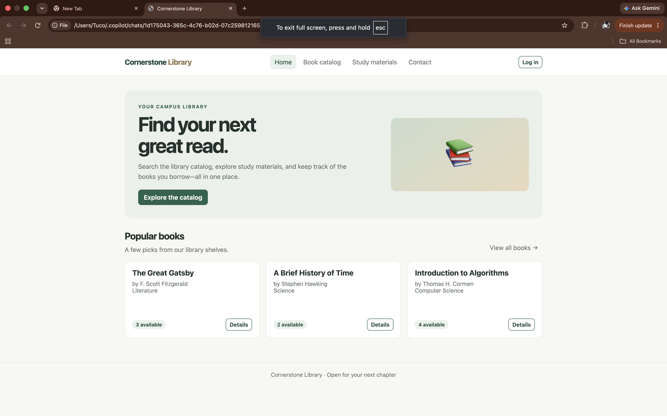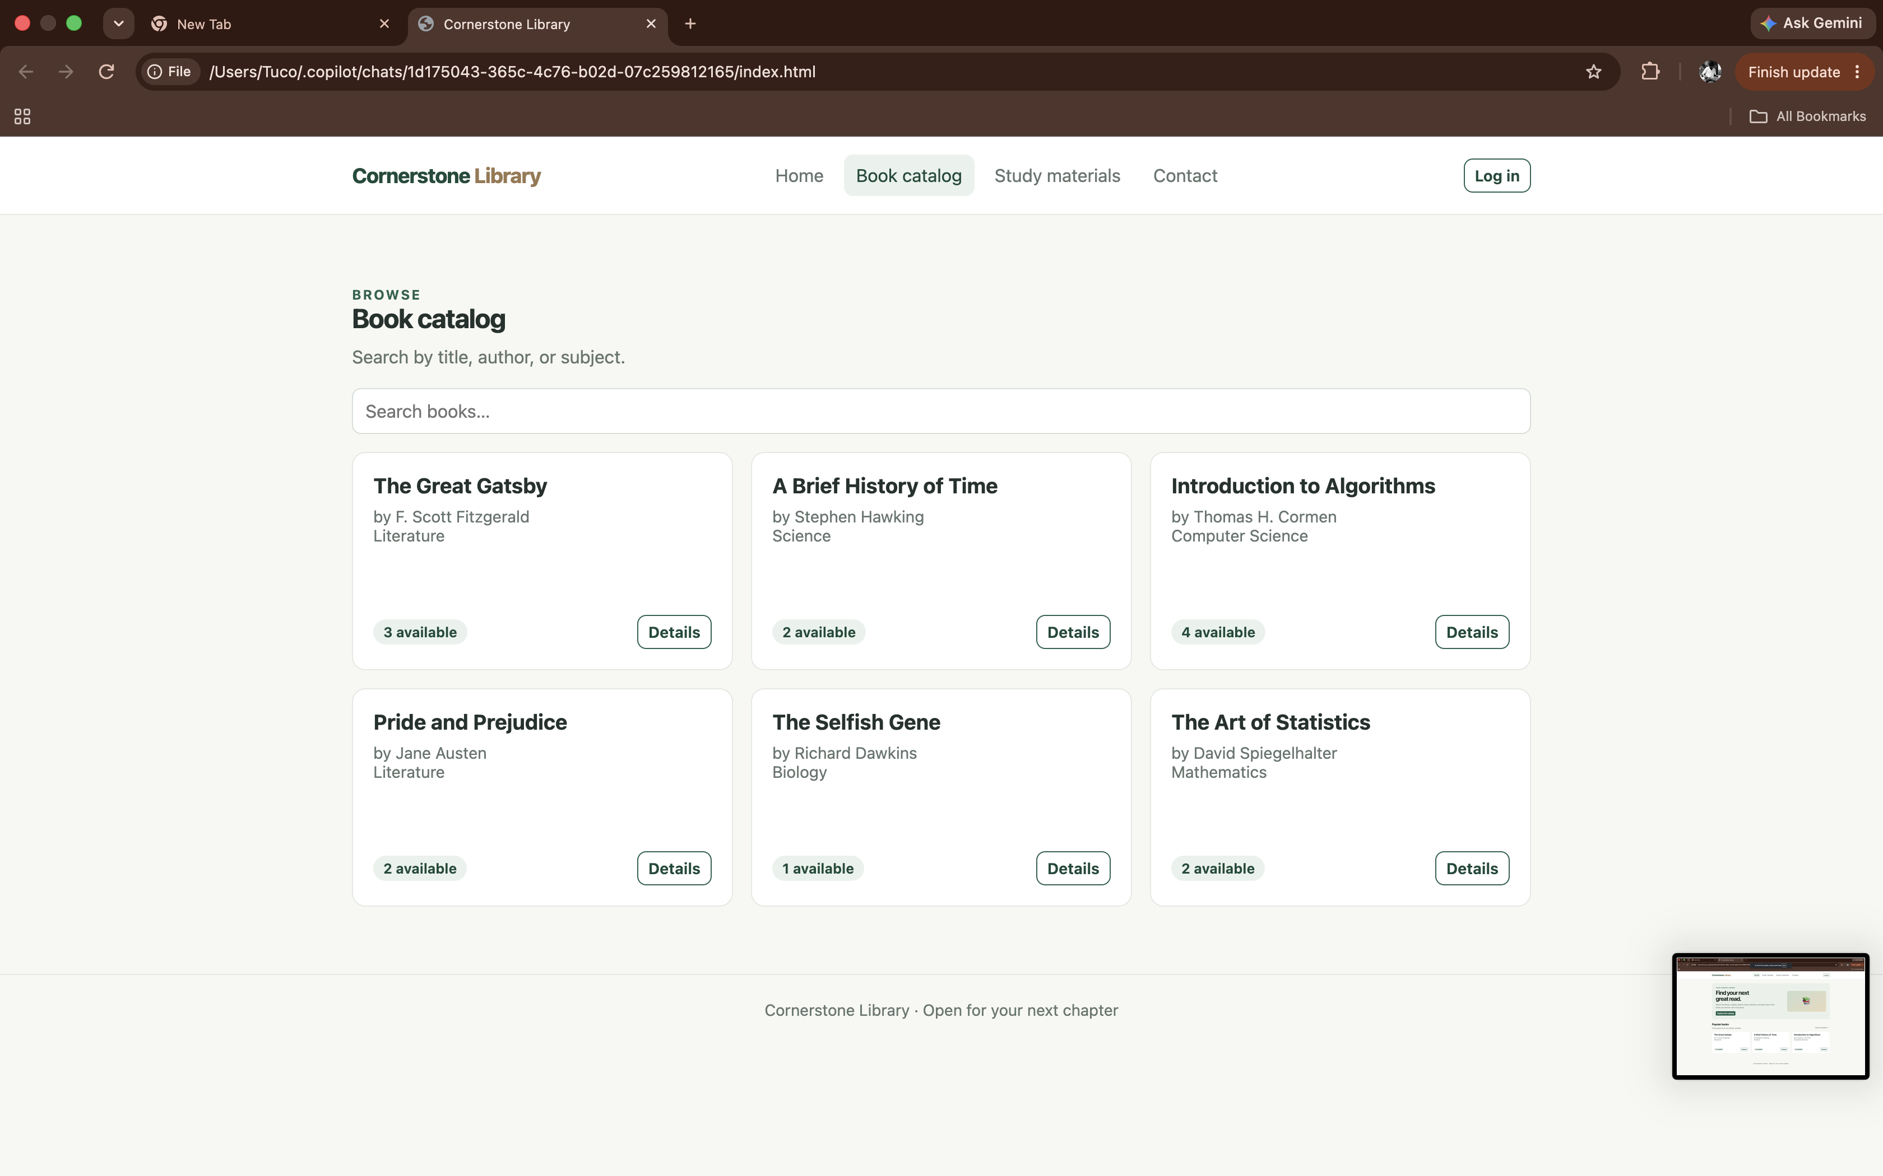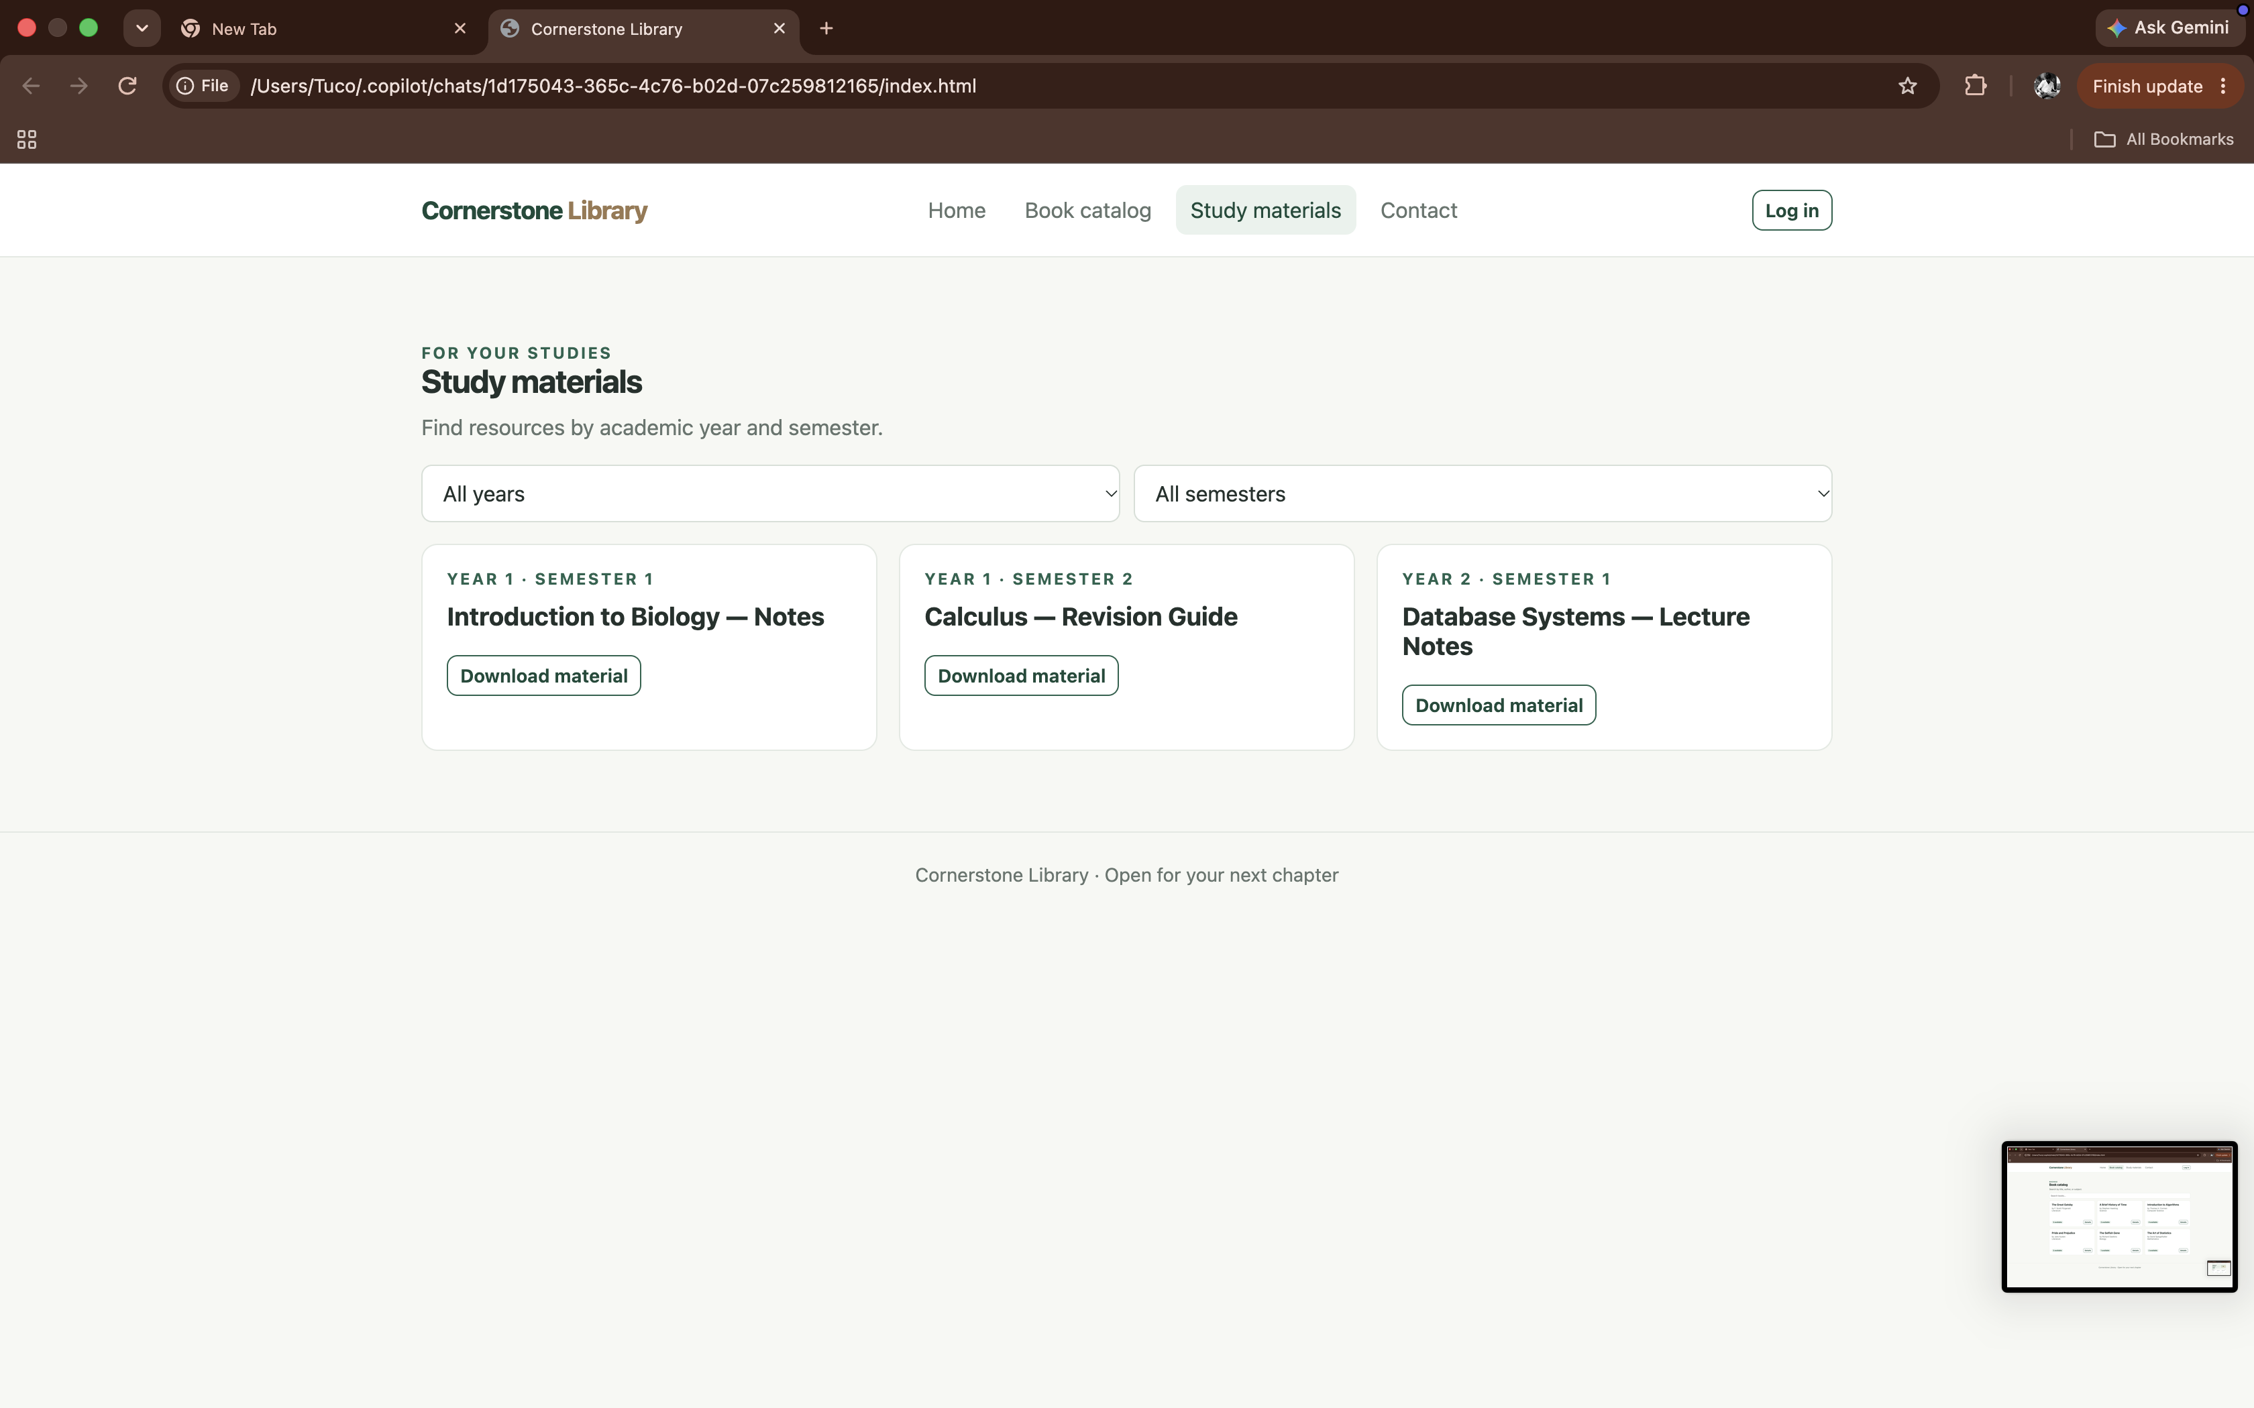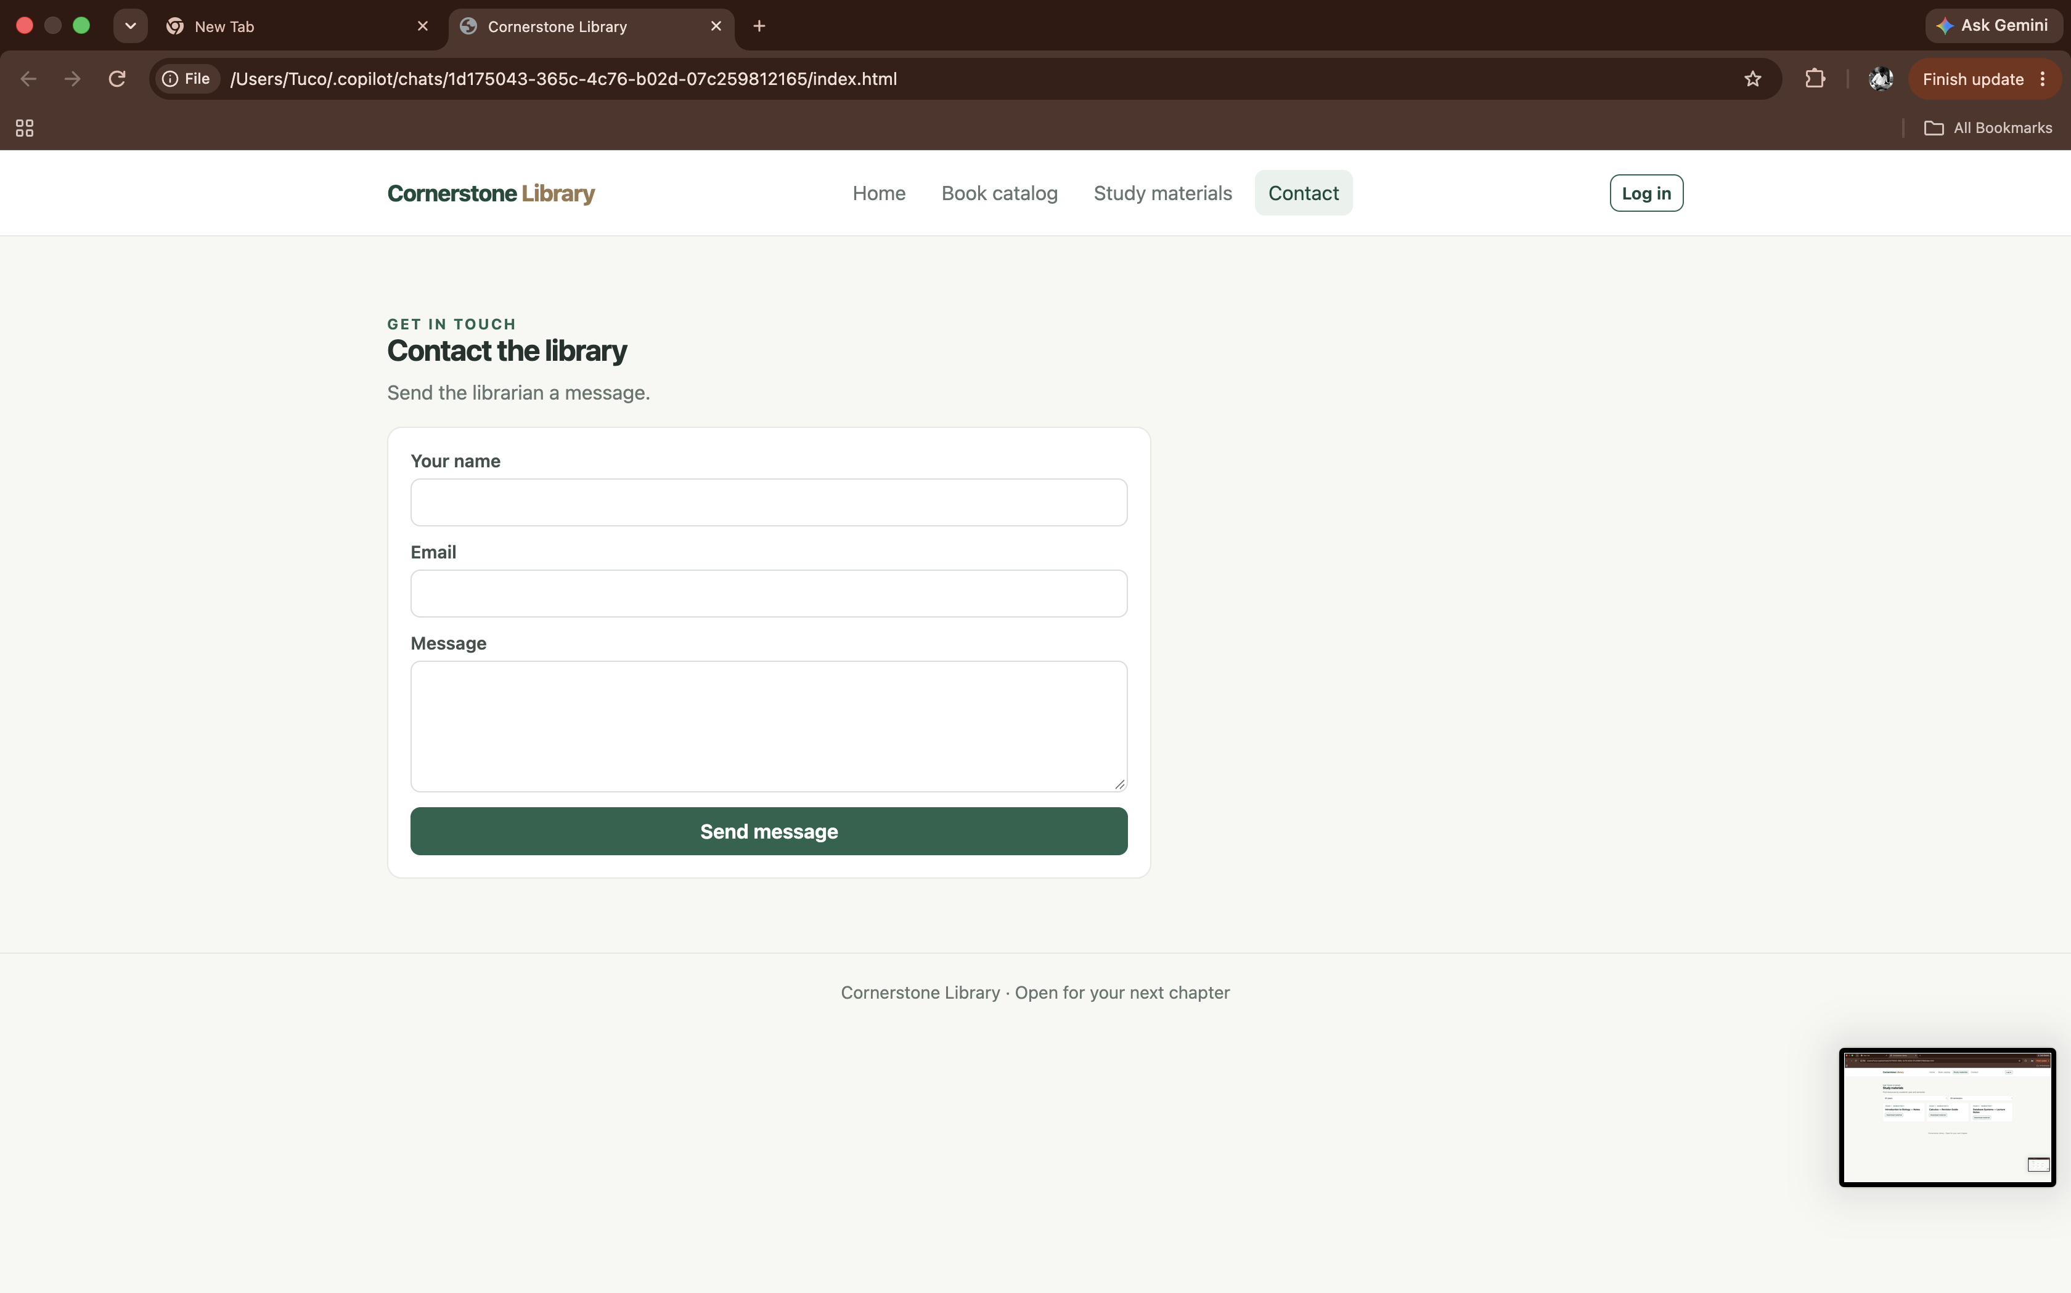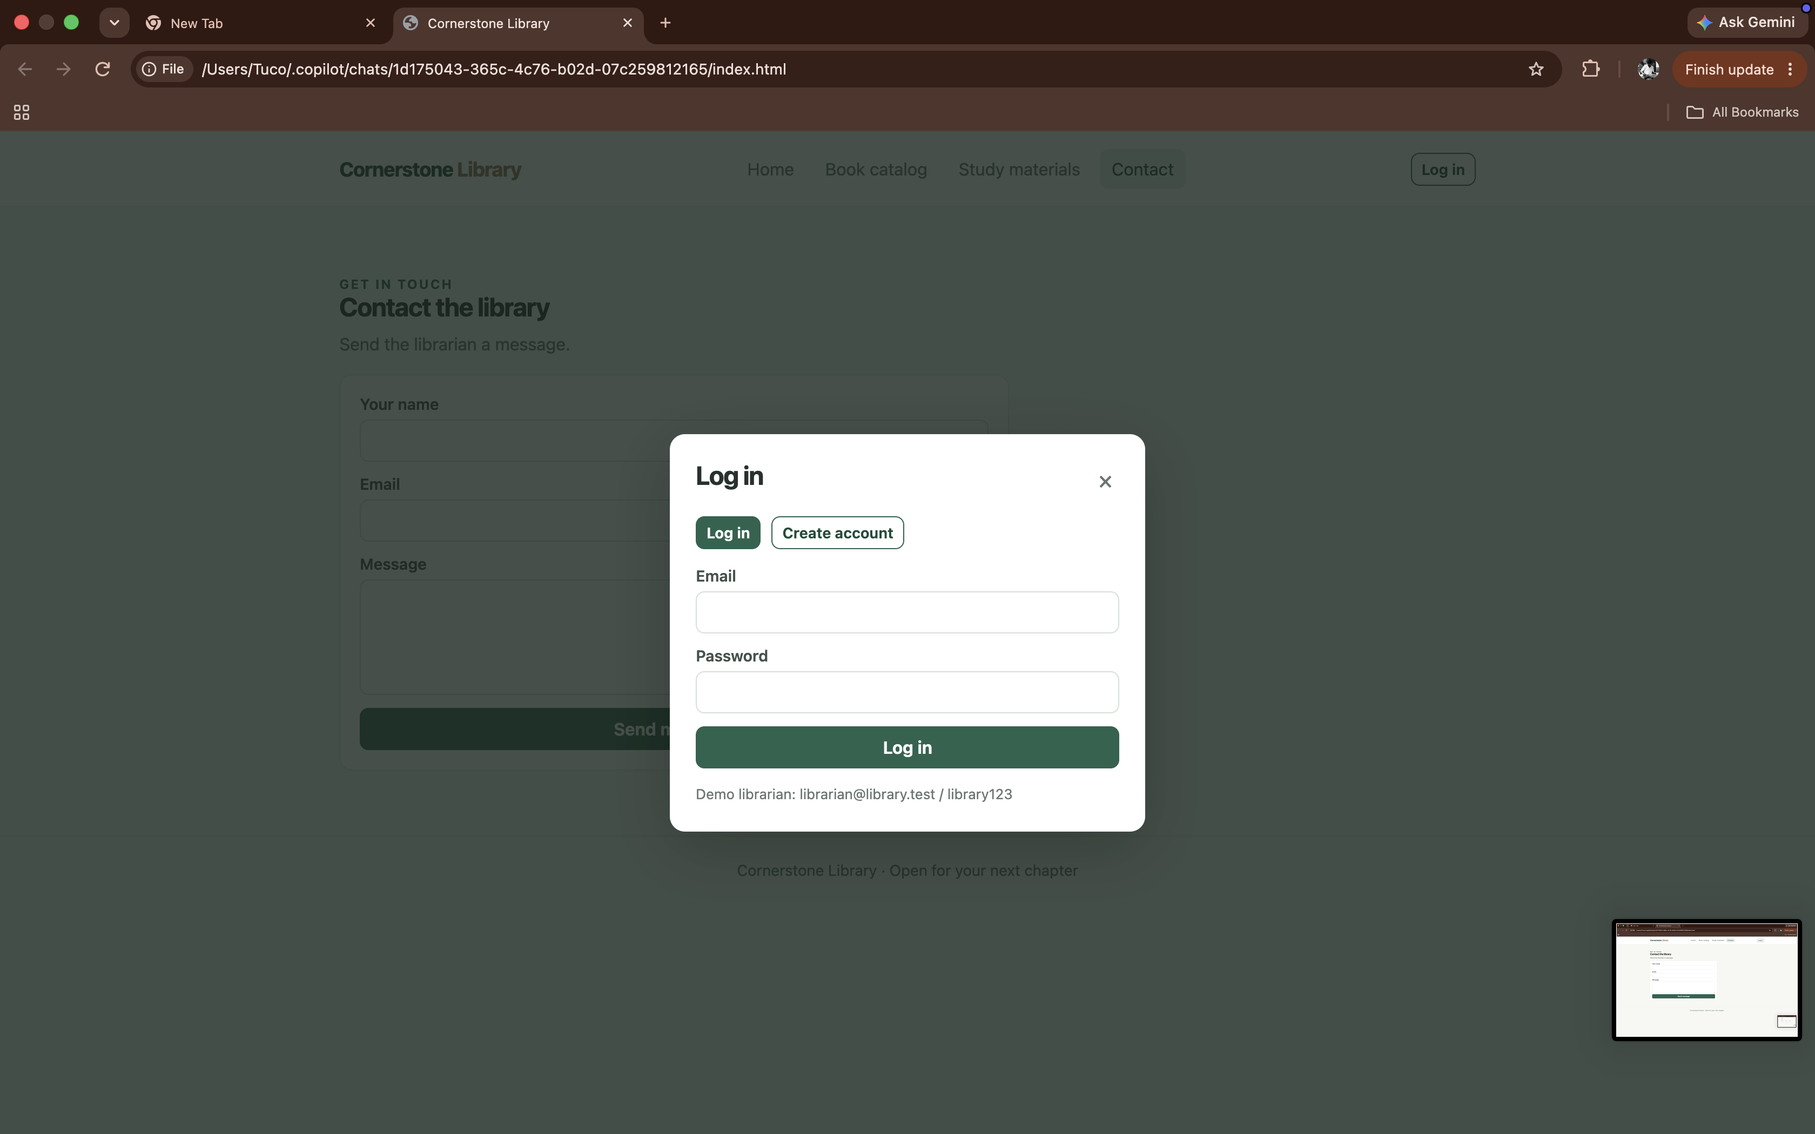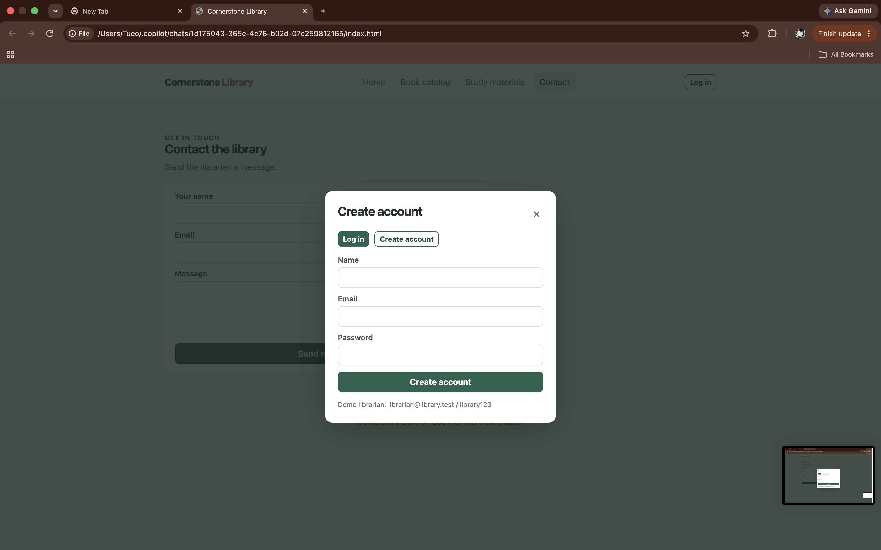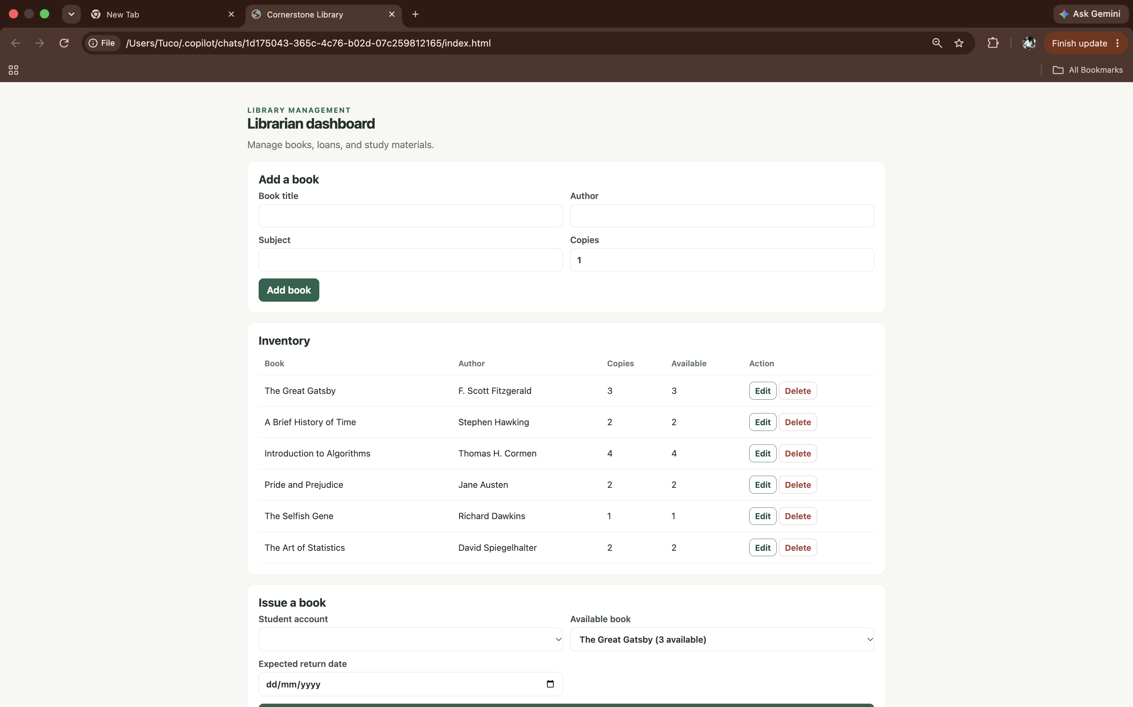

RESULT : The Library Management System was successfully designed to simplify and automate library activities. The system allows librarians to log in, add, update, and delete books, issue books to students, track returns, calculate fines, and manage study materials according to academic year and semester. Students can register, log in, search for books, view book details, check issue and expected return dates, access borrowing history, check outstanding fines, update their profiles, and download study materials. Thus, the system improves the accuracy of library records, reduces manual work, and provides an efficient and user-friendly platform for students and library administrators.

